|  |  |
| --- | --- |
| DATE | 15 NOVEMBER 2022 |
| TEAM ID | PNT2022TMID40456 |
| PROJECT NAME | SMART SOLUTION FOR RAILWAYS |

STEP 1: LOGIN IBM CLOUD

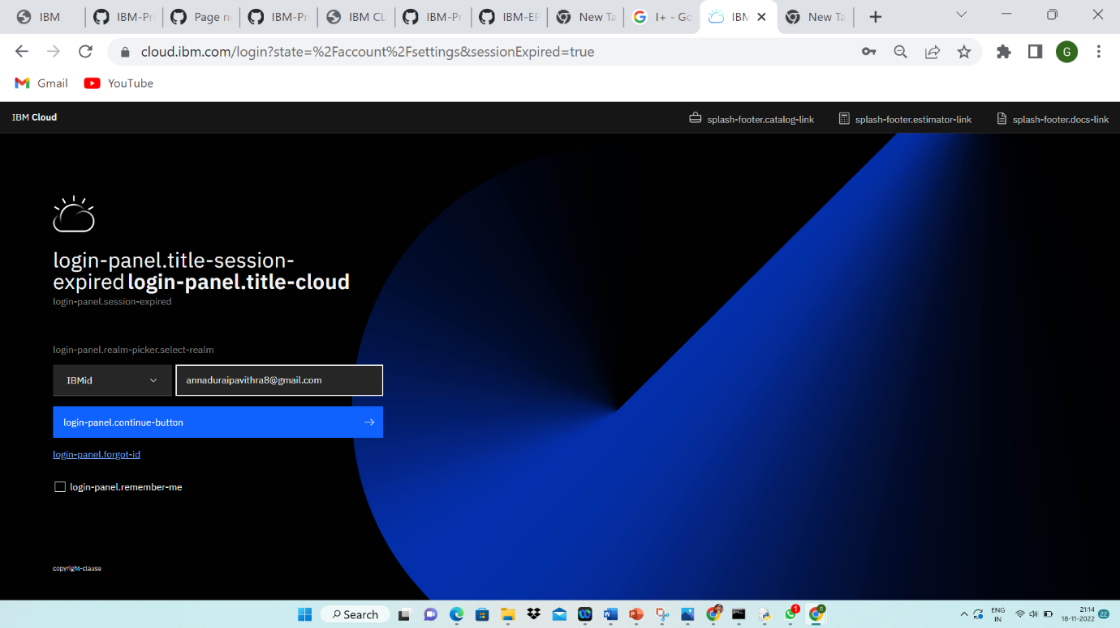

STEP 2:CONFIGURE THE IBM CLOUD SERVICE AND CREATE IOT PLATFORM

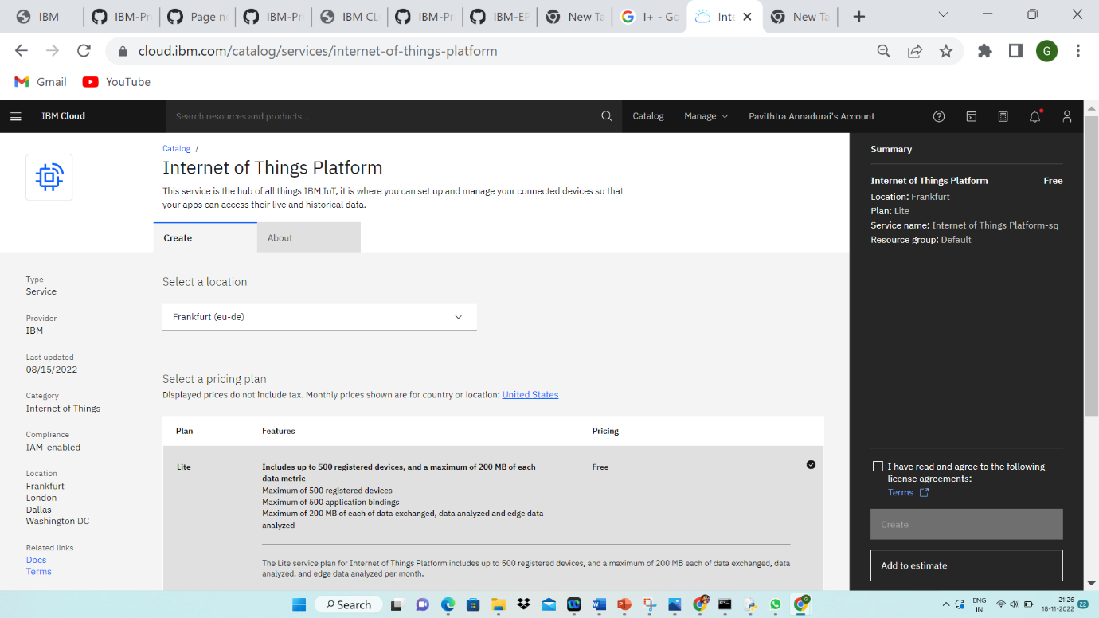

STEP 3

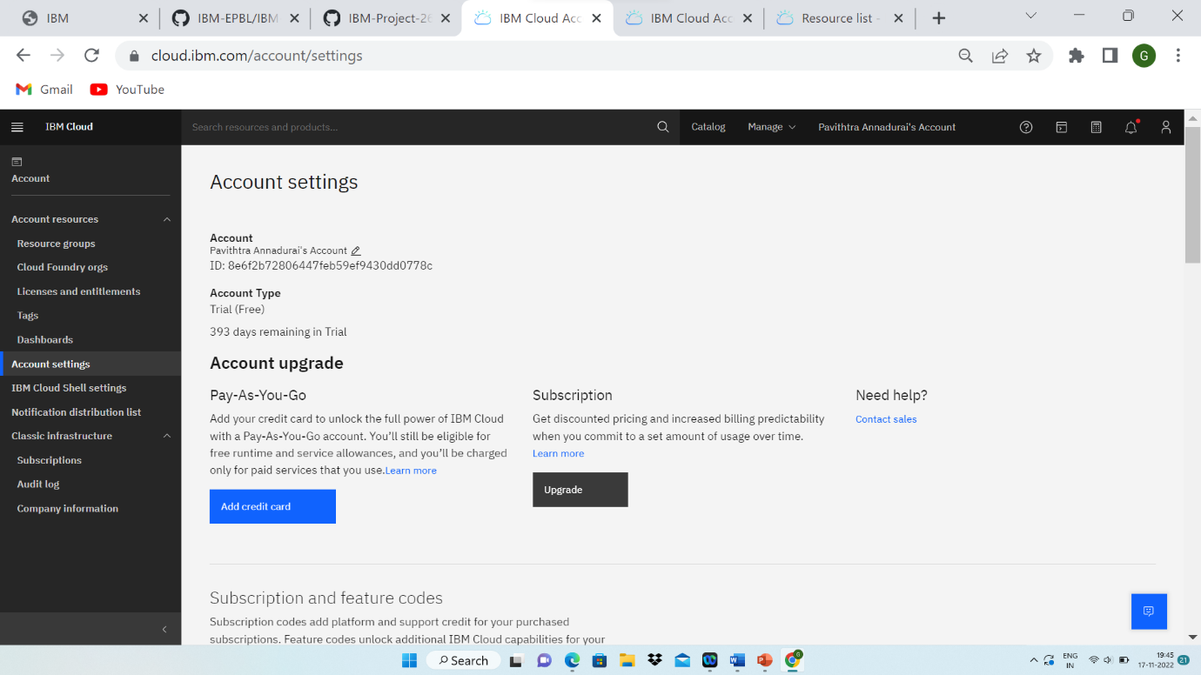

STEP 4

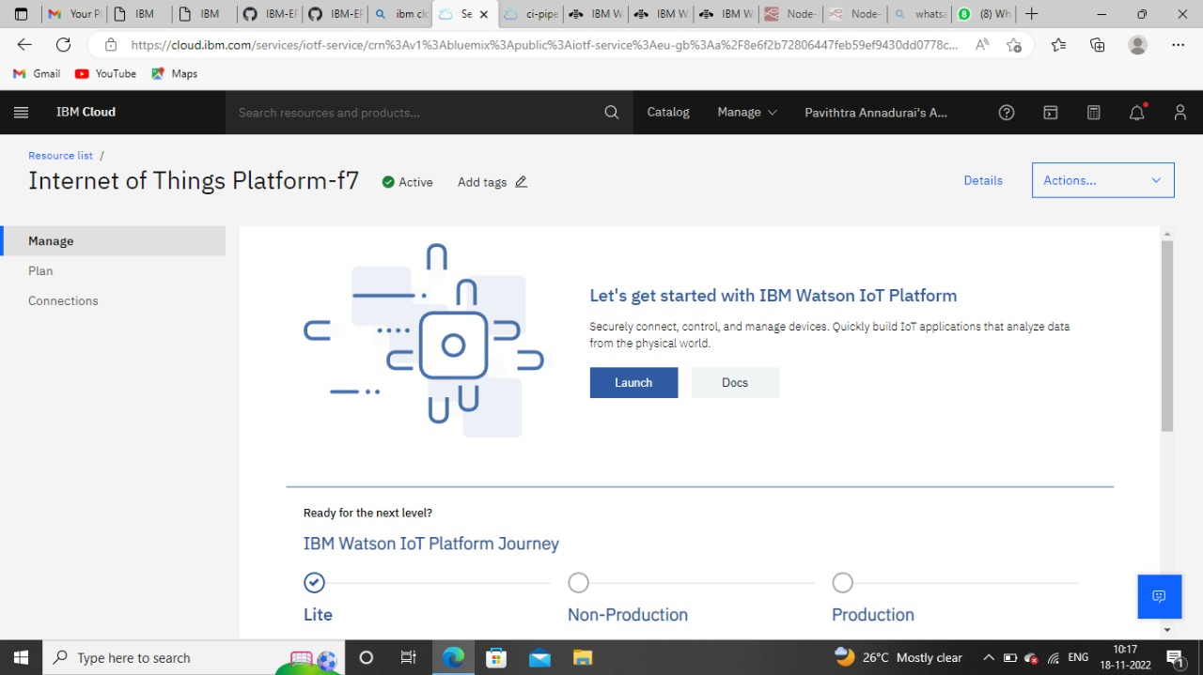

STEP 5:

